Development and Testing of Intelligent Personal Assistant

H. P. Khandagle ^{a,}*, R. Sarodeª, A. Patilª, R. Banadarª, S. Mali, H. A. Tirmareª

ªComputer Science and Technology, Department of Technology, Shivaji University, Kolhapur, 416004 India.

*Corresponding author: hpk_tech@unishivaji.ac.in

ABSTRACT

An Intelligent Personal Assistant (IPA), Virtual Personal Assistant (VPA), or Intelligent Virtual Assistant (IVA) is nothing but a software agent, which performs tasks for each respective user, based on their commands and questions. It helps in doing the work fast, and conveniently and can reduce screen time also. The fundamental advantage of such IPA is the reduction in the cost for the human personal assistant and also reduction of the human errors. This article represents the development and testing of one such IPA named “EDI” which can have a friendly chat to do mathematical operations, just play the media, open applications/software; search on the web, Wikipedia, YouTube, etc. just by a voice giving voice commands. The newly developed EDI is programmed so that, it can interpret human speech, and also respond to individual users with synthetic voices. A python language is used for the development of EDI, which helps in easy programming and fast coding using available libraries. The testing of the developed IPA shows 95 to 100% successful execution of the given commands for various tasks. The innovative feature of the developed IPA is that it can also be used for PCs and laptops.

KEYWORDS

Virtual Personal Assistant, Intelligent Personal Assistant, Speech to Text, Text to speech, Text analyzing
………………………………………………………………………………………….
- INTRODUCTION
Personal assistants are the individuals, who will assist you with some amount fees. Personal assistants help you and assist you in your work. Making you and your work more efficient accurate and fast. Although having a personal assistant can be very useful, not everyone can afford to hire one as hiring one human personal assistant can be very costly. Even though, human personal assistants may be more capable and can do more work than machines they may still do human errors, which may affect your work accordingly. Also, as human beings, they cannot be as perfectly accurate. However, intelligent personal assistant, may not be as capable as humans but is more accurate, fast, and costs very less.
Millennial consumers are looking for more comfortable technology. In this era where speed, efficiency, accuracy, and convenience are constantly being challenged and optimized and it’s very clear that humans are moving towards less user-screen interaction.
The purpose of the development of intelligent personal assistants is to do voice recognition and speak human languages by taking users' commands. Personal intelligent assistants improve the Internet of Things (IoT).
Therefore, this study is aimed to develop an intelligent Personal Assistant that supports speech recognition and text-to-speech (gTTS), which can be very useful and convenient for users. The developed intelligent personal assistant is named ‘EDI’ inspired by a game character. The fundamental purpose of EDI is to be capable of voice and speech interaction, and music playback, EDI enables operation of gadgets PCs, laptops, and their applications. The users can utilize conversational and spoken speech voice instructions. The motivation behind the development of the IPA application is to provide several useful features of a virtual personal assistant VPA to aid task completion. The intelligent personal assistant's primary function is to respond to the user's instructions.
- LITERATURE REVIEW
Di Prospero et al. (2017); Gnewuch et al. (2017) concluded that for chatbots utilization in voice-supported intelligent personal assistants (IPA) and its popularity, the newly designed smart assistants, such as Cortana, Alexa, Google Assistant, and Siri are very useful tools. The domain-specific IPAs are also getting smarter than earlier [1, 2]. Kepuska and Bohouta (2018) concluded that the controversies regarding the similarities and differences between the various IPAs for different applications are still going on. The IPAs are currently installed by the manufacturers of smart devices directly to help users directly [3]. The research shows that using artificial intelligence (AI) and natural language processing (NLP), for different applications, the chatbot form of conversation agents is developed by Nguyen and Sidorova (2018); Jain et al. (2018) [4, 5]. Further, in the next year, Bittner et al. (2019) showed that chatbots can become more professional by improving text-to-speech and speech-to-text communication [6]. There is major competition between intelligent personal assistant service providers. Every company that provides the access to intelligent assistants is looking for more users now and then.
Below are some examples of well-known intelligent assistants.
  - Google Assistant
Google Assistant is an intelligent assistant application developed by Google Inc. It has artificial intelligence making it possible to have a two-way conversation.
- Initially released on 18 May 2016.
- Written in C++ language • Supported operating systems: Android, chrome os, kaios, Linux, IOS
- mobiles and automation devices are the primary use of Google Assistant.
  - Siri
Siri is an intelligent personal assistant program created by Apple Company. Siri also has artificial intelligence.
- Initially released on 4 October 2011
- Written in swift language.
- Supported platforms are iPhone, iPad, apple watch, and iPod touch as mobile devices, and Apple TV as a stationary device. etc.
- Supported OS is IOS 5 onwards for iPhone mobile devices, watch OS for Apple watches, tv OS for apple tv, macOS Sierra for Mac, iPad, etc.
  - Cortana
Cortana is an intelligent assistant software developed by Microsoft. Cortana uses the Bing search engine to perform tasks given by its users.
- Initial release date: 2 April 2014
- Written in C# and some advanced points in c/c++
- Supported platforms: Windows 10, Windows 11, Windows Mobile, Windows Phone 8.1, Microsoft Band 2, Surface Headphones, Harman Kardon Invoke, Skype, Microsoft Band, Cyanogen OS, Windows Mixed Reality, and Amazon Alexa. etc.
- Supported operating systems: Windows, iOS, Android, Xbox OS
The EDI is highly inspired by the above intelligent personal assistants. However, EDI is programmed using Python language, which is very new in the market, and trending EDI are more capable to update with technology. Python language is used for developing EDI, which has very good APIs. It is very easy to create better-looking software/applications from it.
- Friendly chat
- Simple Mathematical Operation
- Complex Mathematical Operations,
- Open the Application by voice
- Internet Applications.
- SYSTEM ARCHITECTURE
For a better understanding of the architecture and workings of EDI, the following diagrams are represented.
  - Activity Diagram
The EDI system is initially in standby mode. It starts processing as soon as it receives any wake-up calls. The following Figure-1 shows the activity diagram of EDI.
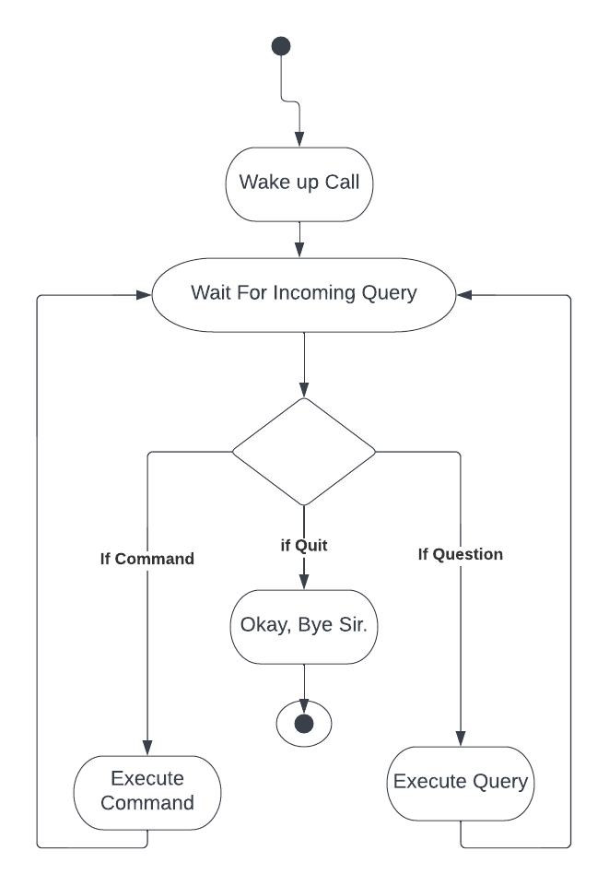
Figure-1: Activity diagram of EDI
The received command is identified whether the user is asking questions or giving tasks. Following the identification of the query or assignment, appropriate action is taken. The EDI pauses for more commands from the user after the question or task has been answered. This loop will run until the quit command is issued.
  - Use case Diagram
EDI can handle only a single user at a time. The user gives commands or asks questions to the EDI. EDI then processes it and answers. The response is sent back to the user. The following Figure-2 represents the use case diagram of EDI.
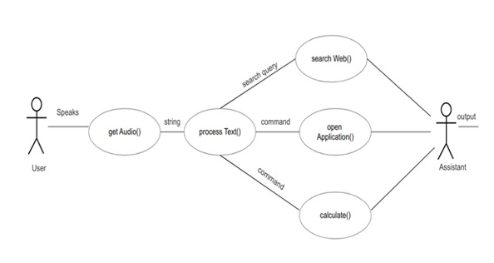
Figure-2: Use case diagram of EDI
  - Dataflow Diagram
The following Figure-1 represents the flow of data/information through the whole user EDI interaction. Also, the subsequent Figure-3 shows the various component diagram and their connections used in EDI.
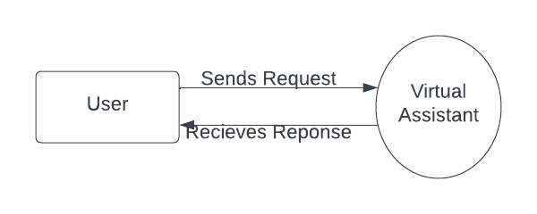
Figure-3: Dataflow diagram of EDI
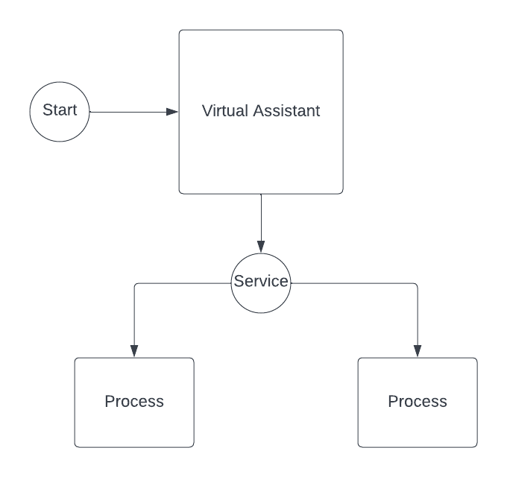
Figure-4: Component diagram
- HARDWARE AND SOFTWARE
  - Hardware
- A working computer that is capable of running Windows OS
- It should be able to run PyCharm and PyCharm libraries.
  - Software
- OS which can run PyCharm software, and gives access to its libraries.
- A web browser so EDI can access the internet
- And if the user asks EDI to open software, it should be installed on the computer first
- PROPOSED TECHNOLOGY APPROACH
  - Python
Python is a class-based high-level, instructive programming language. Python is a powerful, healthy, and extremely useful programming language that is mostly used for Rapid Application Development (RAD). Python Language is very easy to write as well as it is very easy to execute its codes. In comparison to certain other object-oriented programming languages (OOPs), Python may express similar reasoning with as little as nearly one-fifth of the code.
Python has a huge list of advantages over other programming languages. Python programming language has so many applications that it can't be confined to one. Python's popularity has empowered it to participate in a variety of well-known and globally recognized processes, such as data science, AI, ML, and so on. Python has a plethora of libraries to meet this project's needs. In EDI, packages such as speech recognition, gTTs enabling text-to-speech, selenium for online automated processes, and others are utilized.
Python is indeed a proper and systematic programming language. For small cases, efficiency is usually not a hindrance. If current Python code is not effective sufficient, a typical approach to improving it would be to figure out, what is consuming the most duration and re-implement it in a lower-level language. When compared to coding it all in low-level programming, it will result in far less programming and a much more effective program [7].
The intelligent Assistant is indeed the component in this case. It offers two distinct services: Task execution and inquiry answering, among other things.
  - PyCharm Libraries Used for EDI
5.2.1.gTTS:
Google Text-to-Speech (gTTS) is a Python library and command-line interface (CLI) utility. It writes human language to a file, byte strings, or stdout and saves it as digital audio data. Alternatively, one may pre-generate gTTS request URL’s to input into an external software such as an internet browser. Many human-spoken languages are supported by the gTTS-API and python library. The voice could be provided in either of the two audio speeds available: rapid or slow. Figure-5 below represents the working of gTTS [9].
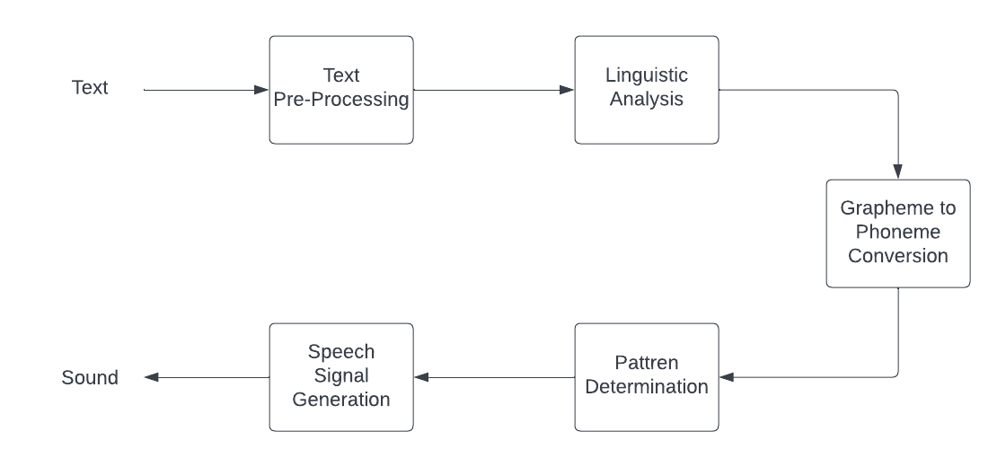
Figure-5: Working of gTTS
5.2.2. Speech Recognition:
The ferry's first component, which is required for speech recognition is spoken words i.e. Speech itself. Via a microphone, the actual sound is turned into an electric or digital signal, which is then converted to digital data with an analog-to-digital processor. Many models can then be used to convert speech into text once it has been converted to digital data.
Speech-to-text conversion, in layman’s terms, means that an app recognizes the words spoken by a person and converts the voice to written text. There are lots of reasons one would want to use Speech-to-Text conversion [8].
Nowadays, Speech Recognition is a very useful feature in several applications used like home automation, AI, and much more. Speech Recognition can also be used on microcontrollers such as Raspberry Pi provided with a microphone. Following Figure-6 shows the working of speech recognition.
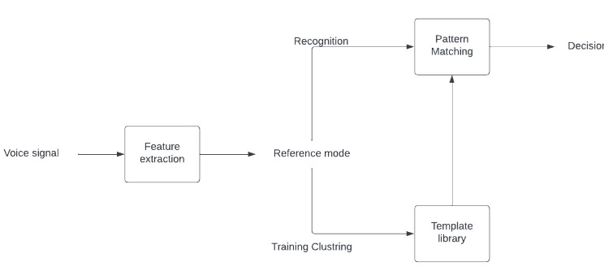
Figure-6: Working of Speech recognition
Speech Recognition has all the scripts required for recognition of speech and accessing the microphone. The Speech Recognition library is very flexible and thus is included and supported in a huge list of APIs. The Google Web Speech API supports a Speech Recognition library's hard-coded default key. Due to the flexibility and usability of the Speech Recognition library, it is used in a high number of Python projects.
Selenium: Selenium Python bindings library provides a simple API to write functional/ acceptance tests using Selenium WebDriver. Using Selenium Python API, one can have access to all functionality of Selenium WebDriver; it also provides an API to pierce Selenium Web motorists like Firefox, Chrome, Remote, etc. Selenium is only supported in the3.5 or advanced performances [10].
- Open Source and Movable • Combination of tool and DSL
- Easier to understand and apply Lower burden and stress for testers
- Cost reduction for the Business Guests
WolframAlpha: The WolframAlpha Webservice API provides a web-grounded API allowing the computational and donation capabilities of Wolfram| Nascence to be integrated into the web, mobile, desktop, and enterprise operations. WolframAlpha is an API that uses Wolfram's techniques and knowledgebase to cipher expert positional replies. This component explains how to create a basic Python auxiliary operation that can respond to simple inquiries such as the ones stated below [11].
5.2.3.Pyaudio:
PyAudio is a Python audio library that works across platforms. It offers more features than ordinary audio libraries, such as recording and continuous audio streaming, but it is heavily reliant on PortAudio, resulting in a more difficult installation. It also includes Python cassettes for PortAudio, a cross-platform audio I/O library, as well as python-sound. Using PyAudio, one will be capable of playing and audio input on a variety of platforms using Python following Figure-7 depicts the working of Pyaudio [12, 13].
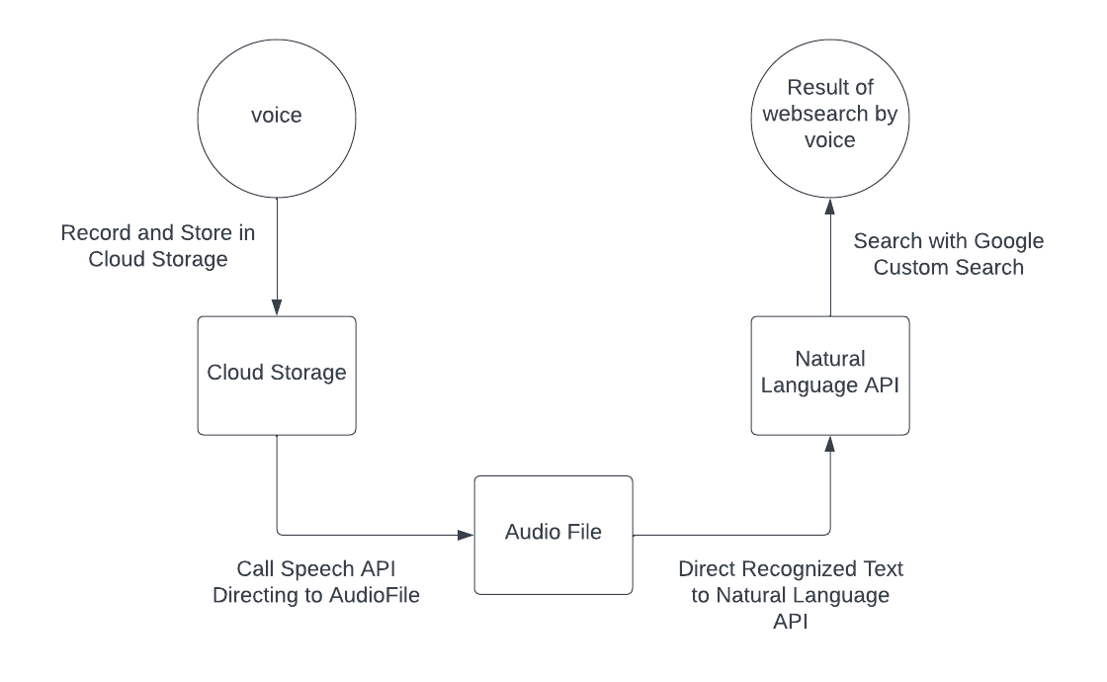
Figure-7: working of Pyaudio
- FEATURES OF EDI
  - Tasks
Tasks are nothing but the desired work given by the user of an intelligent assistant. As EDI is an intelligent assistant, it should also be able to perform various tasks given by the users. EDI should be able to take proper input from the user and perform them and give proper output as well. Voice reorganization and text-to-speech utilities are added for less screen interaction with the user. As, for windows, our intelligent personal assistant is capable of the following tasks.
6.1.1.Friendly chat:
EDI is programmed so that it can have a simple friendly conversation with the user which includes greeting the user and giving self-information the user. Following Figure-8 depicts the friendly chat conversation of EDI.
Figure-8: Friendly Chat conversation
6.1.2.Simple Mathematical Operation:
EDI is programmed so that it can do both simple as well as complex mathematical operations. Figure-9 shows the conversation between the user giving mathematical operation commands to EDI and how EDI responds to the user.

Figure-9: Mathematical operation (Simple)
6.1.3.Complex Mathematical Operations:
Subsequently, the Figure-10 shows the conversation between the user giving complex mathematical operation commands to EDI and how EDI responds to the user.
Figure-10: Mathematical operation (Complex)
6.1.4.Open the Application by voice:
Google Chrome
The following Figure-11 shows the conversation of the user giving open chrome command to EDI and how EDI responds to the user, and Figure-12 shows the Google Chrome opened by EDI after receiving a command from the user
Figure-11: Open application command to open Google chrome
Figure-12: Google application opened by EDI
Microsoft Word
Figure-13 shows the conversation between the user giving an open Microsoft Word command to EDI and how EDI responds to the user. Simultaneously, Figure-14 shows the Google Chrome opened by EDI after receiving a command from the user.
Figure-13: Open application Command to open Microsoft Word
Figure-14: Microsoft Word opened by EDI
  - Internet Application
VPA is programmed to use the internet to help them access data from all other the world uploaded on the internet. Using VPA, users can easily access, engage and customize, the data on the internet. It can be news, weather information, using Wikipedia, voice search on google or playing videos on YouTube.
The developed EDI is programmed as it should perform various tasks regarding the internet. EDI can access the voice web, where the contents of the internet can be accessed using a human voice. EDI uses synthetic voice for human output voice. Using a web browser EDI can access the internet and perform various tasks on the internet.
6.2.1.Websearch by voice:
Google search
Figure-15 shows the conversation between the user giving web search on chrome command to EDI and how EDI responds to the user, and Figure-16 shows the web search done by EDI after receiving the command from the user.
Figure-15: Google web search command
Figure-16: Google web search result
Wikipedia search
Following Figure-17 shows the conversation between the user giving the Wikipedia web search command to EDI and how EDI responds to the user, and similarly, Figure-18 shows the Wikipedia web search done by EDI after receiving the command from the user.
Figure-17: Wikipedia web search command
Figure-18: Wikipedia web search result
YouTube search
Figure-19 shows the conversation between the user giving the YouTube web search command to EDI and how EDI responds to the user, and Figure-20 shows the YouTube web search done by EDI after receiving the command from the user.
Figure-19: YouTube web search command
Figure-20: YouTube web search result
- RESULT OF TESTING
After testing EDI on different machines, different users, different devices, and different OS devices, the results are shown below. The error found is only related to voice recognition and text-to-speech. There is no problem found with the execution of given commands. All tasks are tested and results are given.
  - Offline tasks
These tasks are tested without the need for the internet.
7.1.1.Friendly chat:
Following Table-1 represents the friendly chat command results and Figure-21 shows the accuracy plot of comparison between the success and failure of friendly conversation. It is found that friendly chat with user 1 was 96%, user 2 was 92%, and user 3 was 80% successful.
Table-1. shows the results of the friendly chat commands
Command: Friendly Chat | Success | Failure
User 1 | 96% | 4%
User 2 | 92% | 8%
User 3 | 80% | 20%
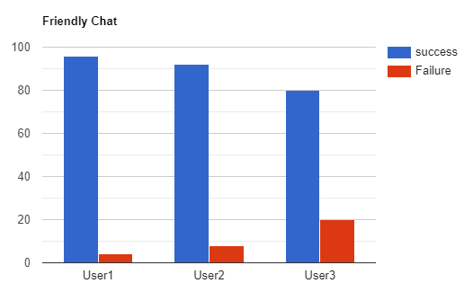
Figure-21: Accuracy plot of comparison of the friendly chat command
7.1.2.Simple mathematical operations:
Following Table-2 depicts the results of our testing of simple mathematical operations, and Figure-22 depicts the comparison plot of the accuracy result of success and failure of simple mathematical commands testing. It is found that addition was 100%, subtraction was 100%, multiplication was 98% and division was 95% successful.
Table-2. shows the results of simple mathematical operation testing
Command: Mathematical Operations (Simple) | Success | Failure
Addition | 100% | 0%
Subtraction | 100% | 0%
Multiplication | 98% | 2%
Division | 95% | 5%
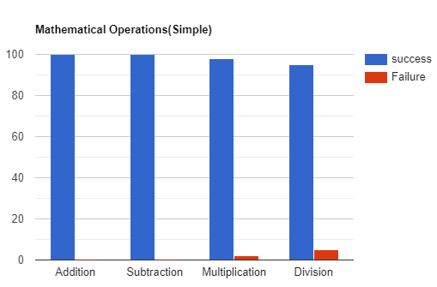
Figure-22: Plot showing a comparison of the accuracy of simple mathematical operation
7.1.3.Complex mathematical operations:
Following Table-3 reveals the result of our testing of complex mathematical operations, and Figure-23 reveals the plot of comparison of the accuracy result graph of success and failure of complex mathematical commands testing. It is found that derivation was 96% and integration was 99% successful.
Table 3: shows the results of complex mathematical operation commands
Command: Mathematical Operations (Complex) | Success | Failure
Derivation | 96% | 4%
Integration | 99% | 1%
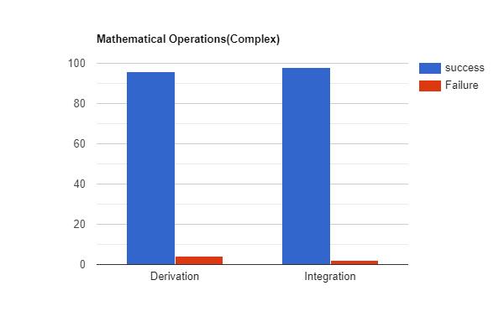
Figure-23: Plot showing a comparison of the accuracy of complex mathematical operation
7.1.4.Open applications by voice:
Following Table-4 depicts the result of our testing of the open application by voice commands on various applications, and Figure-24 depicts the accuracy result plot of the success and failure of open applications by voice commands testing. It is found out opening chrome was 94%, MS WORD is 92%, and excel was 95% successful.
Table 4: shows the results of open application commands
Command: Open Application | Success | Failure
Google Chrome | 96% | 6%
Microsoft Word | 99% | 8%
Microsoft Excel | 96% | 5%

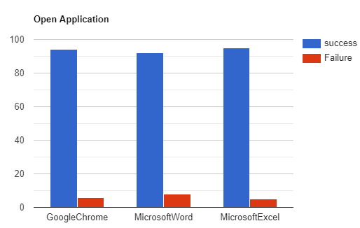
Figure-24: Plot of comparison showing accuracy of open application Internet application
7.1.5.Web search by voice:
Following Table-5 represents the result of our testing of web search by voice commands on various applications, and Figure-25 represents the comparison plot of the accuracy result of success and failure of Web search by voice commands testing. It is found web search by voice in chrome is 96%. Wikipedia was 93%, and YouTube is 98% successful.
Table 5: represents the results of our testing of web search by voice commands on various applications
Command: Open Application | Success | Failure
Chrome | 96% | 4%
Wikipedia | 93% | 7%
YouTube | 98% | 2%
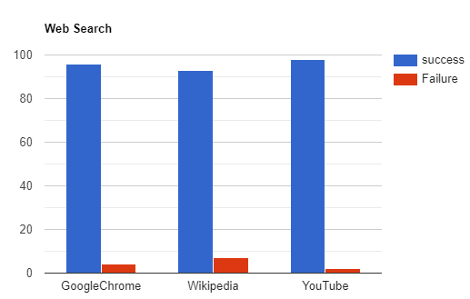
Figure-25: Plot of comparison showing accuracy result of success and failure of Web search by voice commands testing

- CONCLUSION
This paper represents the development and testing of an intelligent personal assistant or virtual personal assistant named EDI after a video game character. EDI is developed using the python language and executed on PyCharm an Integrated Development Environment IDE in short using its libraries. The EDI can have friendly chat, do mathematical operations, open software installed on a PC, do a web search, do a Wikipedia search, and do a YouTube search. The EDI is tested several times and found almost no errors showing accuracy and reliability. The real-time intelligent personal assistant EDI is a very useful tool for various operations not only on mobiles and gadgets but also on PCs and laptops. The newly developed EDI is programmed so that, it can interpret human speech, and also respond to individual users with synthetic voices. A python language is used for the development of EDI, which helps in easy programming and fast coding using available libraries. The testing of the developed IPA shows 95 to 100% successful execution of the given commands for various tasks.

REFERENCES
- Di Prospero A, Norouzi N, Fokaefs M, Litoiu M, (2017), Proceedings of the 27th annual international conference on computer science and software engineering. Markham, 76–86
- U Gnewuch, S Morana, A Maedche, (2017), In: ICIS proceedings. Seoul, 1–14
- V Kepuska, G Bohouta, (2018), IEEE 8th CCWC proceedings. Las Vegas, 99–103
- QN Nguyen, A Sidorova, (2018), AMCIS proceedings. New Orleans, 1–5
- M Jain, P Kumar, R Kota, S Patel, (2018), Designing interactive system conference. Hong Kong, 895–906
- E Bittner, S Oeste-Reiß, J Leimeister, (2019), HICCS 52 proceedings. Maui, 284–293
- A. Stewart, (2017), Python Programming: Python Programming for Beginners, 1st ed. Create Space Independent Publishing Platform.
- N. Manaswi, S John, (2018), USA: Apress, 31-43.
- PyAudio documentation. PyAudio Documentation - PyAudio 0.2.1 documentation. (n.d.), (2022), https://people.csail.mit.edu/hubert/pyaudio/docs/
- "gTTS", PyPI, (2022), [Online]. Available: https://pypi.org/project/gTTS/.
- "selenium", PyPI, (2022) [Online]. Available: https://pypi.org/project/selenium/.
- "wolframalpha", PyPI, (2022), [Online]. Available: https://pypi.org/project/wolframalpha/.
- "PyAudio", PyPI, (2022), [Online]. Available: https://pypi.org/project/PyAudio/.

